Reading Spine – Oak

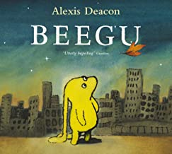 | Beegu by Alexis Deacon  Beegu is not supposed to be on Earth. She is lost. She is a friendly little creature, but the Earth People don't seem very welcoming at all. However, so far she has only met the BIG ones. The little ones are a different matter . .
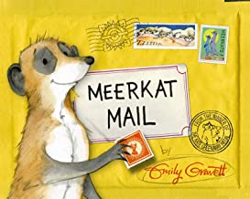 | Meerkat Mail by Emily Gravett  Sunny the meerkat lives with his enormous family in the Kalahari desert. They are all very close . . . so close, in fact, that one day Sunny decides it's just too crowded and packs his bags. He's off to visit his mongoose cousins. But from the watery world of the Marsh Mongoose to the nocturnal lifestyle of the Malagasy Mongoose, Sunny just doesn't fit in. And who's that shadowy figure who seems to be following him around?
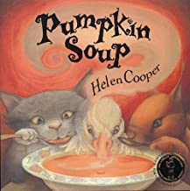 | Pumpkin Soup by Helen Cooper  Cat, Duck and Squirrel live in an old white cabin, with a pumpkin patch in the garden. Every day Cat slices up some pumpkin, Squirrel stirs in some water and Duck tips in some salt to make perfect pumpkin soup... until the day Duck wants to do the stirring...  A funny, rhythmical story about friendship and sharing, with fabulous animal characters, illustrated in glowing autumnal colours, which received rave reviews in hardback.
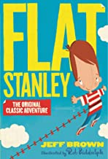 | Flat Stanley by Jeff Brown  Stanley Lambchop was just an ordinary boy – until a noticeboard fell on him. Now he’s flat as a pancake!  Being flat is fantastic – he can be rolled up, sent in the post and even fly like a kite. But it’s not all fun and games . . . there are thieves in town. Can Flat Stanley be a hero?
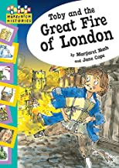 | Toby and the Great Fire of London by Margaret Nash  Toby has forgotten a delivery for Mr Pepys, but as he sets out across London he sees the sky is full of flames!
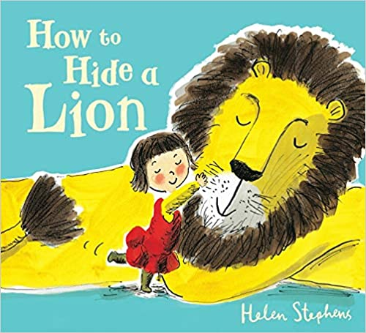 | How to Hide a Lion by Helen Stephans  How does a very small girl hide a very large lion?  It's not easy, but Iris has to do her best, because mums and dads can be funny about having a lion in the house.  Luckily, there are lots of good places to hide a lion - behind the shower curtain, in your bed, and even up a tree.  But Iris can't hide her lion forever, and when her mum discovers him, he has to run away and hide all on his own.  When the lion sees three robbers stealing from the town hall, it's his chance to show everyone that he is, after all, a kind (and very brave) lion – just like Iris always said.
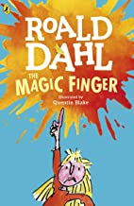 | The Magic Finger by Roald Dahl  Every Saturday morning the Greg family goes off to shoot animals and birds. But the girl who lives next door hates hunting.  Now it's made her so angry she's PUT THE MAGIC FINGER ON THEM ALL. And very strange things have begun to happen . . .
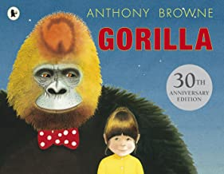 | Gorilla by Anthony Browne  Hannah loves gorillas but has never seen one. Her father's too busy to take her to the zoo – or for anything else come to that. For her birthday, Hannah asks her father for a gorilla – but is disappointed when she discovers that the gorilla she's got is just a toy one. But then something extraordinary happens ... the toy turns into a real gorilla, who puts on her father's hat and coat and takes her off for a magical visit to the zoo...
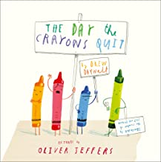 | The Day the Crayons Quit by Oliver Jeffers  A re-telling of the classic children's story by the author and illustrator of the best-selling Snowman. Jim finds a beanstalk growing outside his window one morning, and follows his famous predecessor up to the top . . .
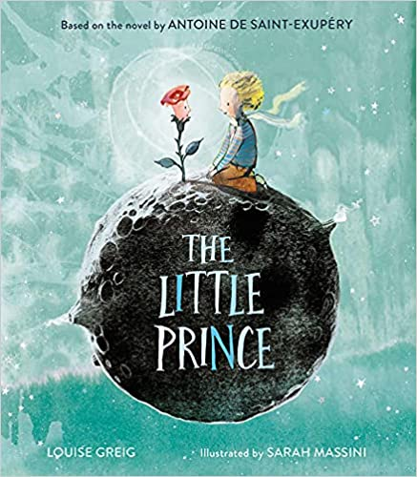 | The Little Prince by Antoine de Saint-Exupery  Please – draw me a sheep.  I blinked.  The voice belonged to a charming little prince.  The characters of Antoine de Saint-Exupéry's classic tale have captured the hearts of generations of readers. Meet the pilot stranded in the desert. Meet the Little Prince who tends his beautiful rose on a planet of his own. Follow him as he embarks on a strange and wonderful journey to puzzling new planets and finally to Earth, where he discovers the nature of love.
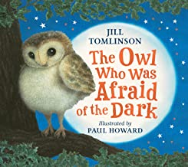 | The Owl who was Afraid of the Dark by Jill Tomlinson  Plop, the baby owl, is like every barn owl there ever was, except for one thing – he is afraid of the dark . . .  The dark is brimming with excitement and magic. As Plop ventures into the night, he meets a boy who shows him fireworks, a black cat who takes him exploring, a girl who tells him about Father Christmas, among other surprising discoveries . . .
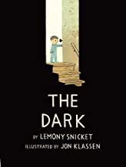 | The Dark by Lemony Snicket  Laszlo is afraid of the dark. The dark lives in the same house as Laszlo but mostly it spends its time in the basement. It doesn't visit Laszlo in his room. Until one night it does . . . Join Lazlo on his journey to meet the dark, and find out why it will never bother him again.  With emotional insight and poetic economy, two world-renowned talents of children's literature bring to light a powerful story about overcoming fears.
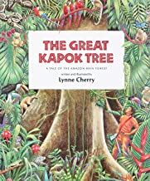 | The Great Kapok Tree by Lynne Cherry  A man starts to chop down a great kapok tree in the rainforest. Exhausted from his labours, he puts down his axe and rests, but as he sleeps the animals who live in the tree come and plead with him not to destroy their world.
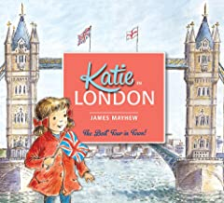 | Katie in London by James Mayhew  When Katie and her brother Jack visit London with Grandma, something very unexpected happens . . . One of the Trafalgar Square lions comes to life and takes them on a wonderful tour of all the best sights! Including Buckingham Palace, the Tower of London, Big Ben and the London Eye.
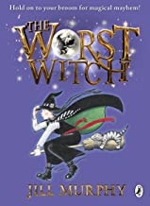 | The Worst Witch  Hold on to your broomstick for magical mayhem with Jill Murphy's much-loved classic The Worst Witch- the original story of life at a magical boarding school.  Mildred Hubble is a trainee at Miss Cackle's Academy for Witches, but she's making an awful mess of it.  She keeps getting her spells wrong and crashing her broomstick. And when she turns Ethel, the teacher's pet into her worst enemy, chaos ensues...
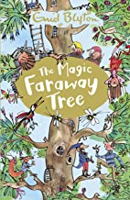 | The Magic Faraway Tree by Enid Blyton  Joe, Beth and Frannie's cousin Dick comes to stay, reluctant at first to share in their adventures at the top of the Faraway Tree. Join them and their friends Moonface, Saucepan Man and Silky the fairy as they discover which new land is at the top of the Faraway Tree. Will it be the Land of Spells, the Land of Treats, or the Land of Do-As-You-Please? Come on an amazing adventure!
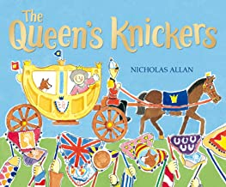 | Queens Knickers by Nicholas Allan  It's a busy year for the Queen - she has lots of important events to attend. Meanwhile, a little girl is wondering what knickers Her Majesty will choose to wear on a school visit! Will they be her 'at home' knickers - adorned with corgis - or her 'garden party' knickers, or perhaps her woolly Balmoral ones...?
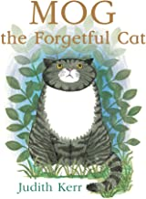 | Mog by Judith Kerr  Mog the Forgetful Cat was first published in 1970 and has never been out of print! The classic picture book story of a very forgetful cat, her family, and a very exciting adventure is the perfect gift for families, boys, girls, and anyone who has ever known or loved a cat.
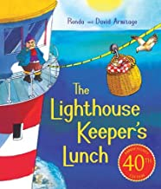 | The Lighthouse Keepers Lunch by Ronda & David Armitage  Once there was a lighthouse keeper called Mr. Grinling. At night time he lived in a small white cottage perched high on the cliffs, and in the daytime he rowed out to his lighthouse to clean and polish the light. Every day Mr Grinling tucks into delicious lunch, prepared by his wife, Mrs Grinling. But Mr Grinling isn't the only one who enjoys the tasty food, so Mrs Grinling has to think of a way to stop the greedy seagulls from stealing the lighthouse keeper's lunch. First published forty years ago, THE LIGHTHOUSE KEEPER'S LUNCH has become a modern picture book classic and is loved by children everywhere.
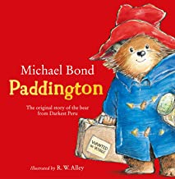 | Paddington by Michael Bond  Paddington Bear first met the Brown family at a railway station – Paddington station, in fact. He had travelled all the way from Darkest Peru with only a jar of marmalade, a suitcase and a label reading ‘Please look after this bear’. Without further ado, Mr and Mrs Brown promptly welcomed the adventurous bear into their family, and in honour of their meeting place they named him Paddington.  The Browns soon discover that Paddington is a most unusual bear. Ordinary things – like having a bath – become quite extraordinary when a bear called Paddington is around.

