Reading Spine – Little Acorns

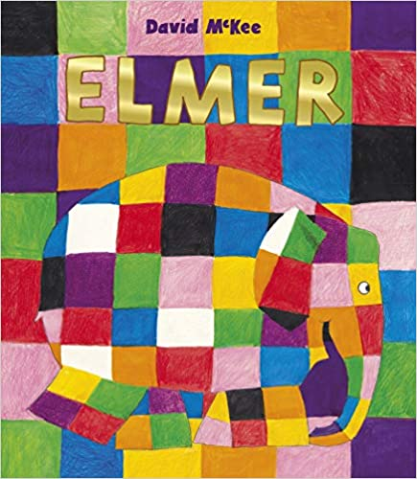 | Elmer by David McKee  Elmer is different. Elmer is patchwork.  The grey elephants all love him, but he soon starts to wonder what it would be like to be just the same as them...
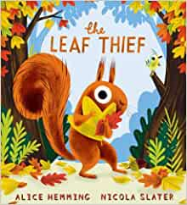 | The Leaf Thief by Alice Hemming & Nicola Slater  Squirrel is so cross.  Yesterday there were loads of beautiful leaves on his tree, but today? Today some are missing and Squirrel is convinced that someone has stolen them...  there's a leaf thief on the loose!  Join Squirrel on a mission to find the culprit, and meet so many fun animals on the way, while you find out how the world takes on different colours as the months pass by.
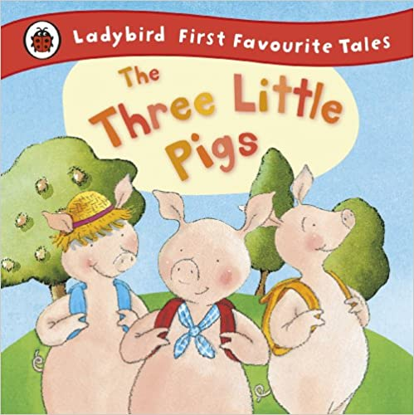 | Traditional Tales – The Three Little Pigs  Join the three little pigs as they set off to see the world, build their houses and encounter the big, bad wolf. This hardback book contains amusing pictures and lots of funny rhythm and rhyme to delight young children. Ideal for reading aloud and sharing with 2-4 year olds.
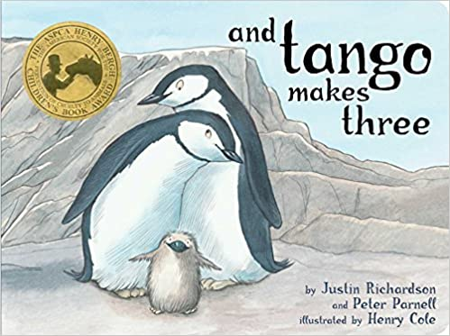 | And Tango Makes Three by Julia Richardson & Peter Parnell  At the penguin house at the Central Park Zoo, two penguins named Roy and Silo were a little bit different from the others. But their desire for a family was the same. And with the help of a kindly zookeeper, Roy and Silo got the chance to welcome a baby penguin of their very own.
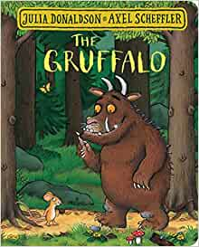 | The Gruffalo by Julia Donaldson & Axel Scheffler  Walk further into the deep dark wood, and discover what happens when a quick-witted mouse comes face to face with an owl, a snake... and a hungry Gruffalo!
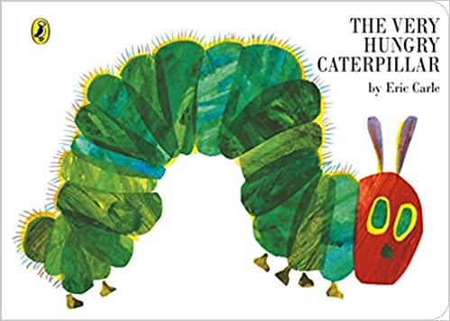 | The Very Hungry Caterpillar by Eric Carle  Eric Carles The Very Hungry Caterpillar is a perennial favourite with children and adults alike Its imaginative illustration and clever cutout detail charts the progress of a very hungry caterpillar as he eats his way through the week.
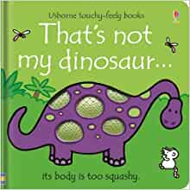 | That’s not my Dinosaur  Meet five friendly dinosaurs in this special edition of the much-loved That's not my... book. Babies and toddlers will love touching the textured patches as they meet dinosaurs with fuzzy tails, bumpy teeth and soft spines. The bright pictures and textures to stroke are designed to help develop sensory and language awareness.
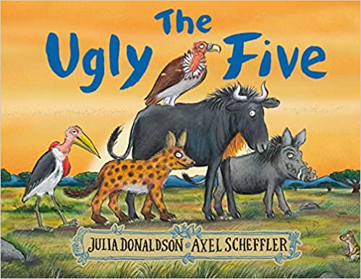 | The Ugly Five by Julia Donaldson & Axel Scheffler  Who's that singing on the savannah?  The wildebeest, warthog, vulture, hyena and marabou stork swagger proudly across the savannah, rejoicing in their ugliness - and delighting their babies, who think they're perfect just the way they are.
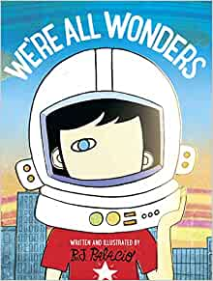 | We are all Wonders by R J Palacio  With spare, powerful text and richly-imagined illustrations, We're All Wonders shows readers what it's like to live in Auggie's world - a world in which he feels like any other kid, but he's not always seen that way.  We're All Wonders taps into every child's longing to belong, and to be seen for who they truly are. It's the perfect way for families and teachers to talk about empathy, difference and kindness with young children.
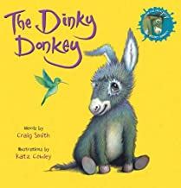 | Dinky Donkey by Craig Smith  Meet the wonky donkey's dinky daughter in this hilarious sequel to the laugh-out-loud viral sensation The Wonky Donkey. Read along as she gets up to all sorts of antics in this adorable picture book written by Craig Smith and illustrated by Katz Cowley.
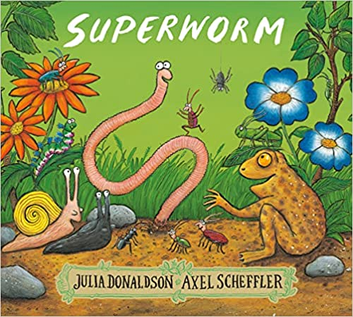 | Superworm by Julia Donaldson & Axel Scheffler  Meet the wiggliest, squiggliest superhero in the world  “Superworm is super-long.  Superworm is super-strong.  Watch him wiggle! See him squirm!  Hip, hip, hooray for SUPERWORM!”  Super-long and super-strong, Superworm is always on hand to help animals and insects in need.  From rescuing Baby Toad from a busy road or fishing Beetle out of a well – do not fear, Superworm is here!  But who will come to Superworm's rescue, when he’s captured by the wicked Wizard Lizard and Crow?  Luckily, all of Superworm’s friends have a cunning plan...
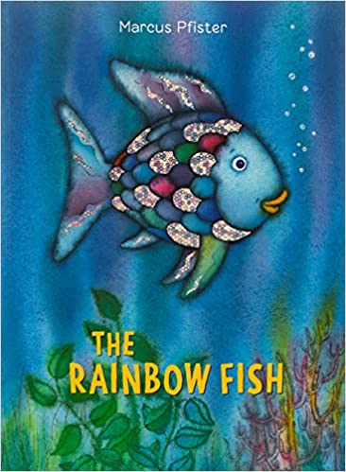 | The Rainbow Fish by Marcus Pfister  In the beginning, the most beautiful fish in the ocean does not want to share one of his shining scales with a little blue fish. All the other fish in the sea ignore him after this and he does not understand why. He goes to the wise octopus for advice, and she tells him to give away his scales. Rainbow Fish reluctantly gives away all but one of his scales. In the end, he is less beautiful than he was before, but he has new friends and is now the happiest fish in the sea.

