Reading Spine – Chestnut

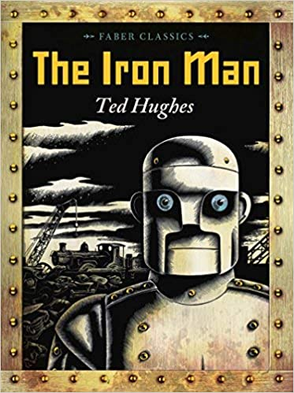 | The Iron Man by Ten Hughes  The Iron Man came to the top of the cliff. Where had he come from? Nobody knows. How was he made? Nobody knows. Mankind must put a stop to the dreadful destruction by the Iron Man and set a trap for him, but he cannot be kept down. Then, when a terrible monster from outer space threatens to lay waste to the planet, it is the Iron Man who finds a way to save the world.
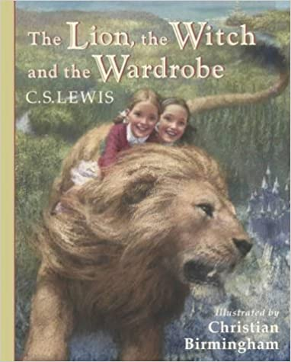 | The Lion, the Witch and the Wardrobe by C S Lewis  When the Pevensie children - Peter, Susan, Edmund and Lucy - step through a wardrobe door in the strange country house where they are staying, they find themselves in the land of Narnia. Frozen in eternal winter, Narnia is a land of snow and pine forests, and its creatures are enslaved by the terrible White Witch.
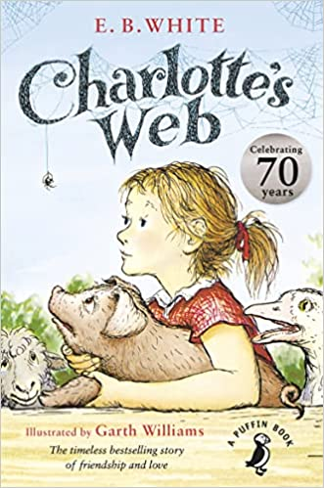 | Charlottes Web by Garth Williams  A poignant, humorous story of a pig, a spider and a little girl.  Wilbur the pig's life has already been saved by Fern, but when he is sold to her uncle, he realises his life is in even more danger. Enter Charlotte A. Cavatica, a beautiful large grey spider.  Charlotte is determined to keep Wilbur from the chopping block, and comes up with an ingenious way to do just that.
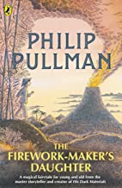 | The Firework Makers Daughter by Philip Pullman  Lila doesn't just want to be a Firework-Maker's daughter, she wants to be a Firework Maker herself. But although she's learned a lot she still must get through the most difficult and dangerous part of her apprenticeship - and her father won't tell her what it is.  In search of this final Firework-Making secret, Lila heads off alone on a journey. It is a journey filled with dangers beyond anything she could have imagined, a journey on which she will learn so much more than the one secret she set out to find . . .
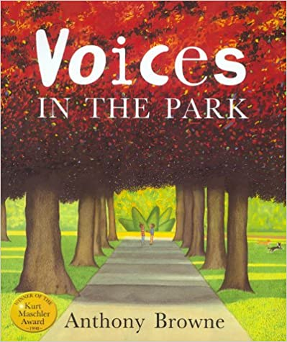 | Voices in the Park by Anthony Browne  Four different voices tell their own versions of the same walk in the park. The radically different perspectives give a fascinating depth to this simple story which explores many of the author's key themes, such as alienation, friendship and the bizarre amid the mundane.
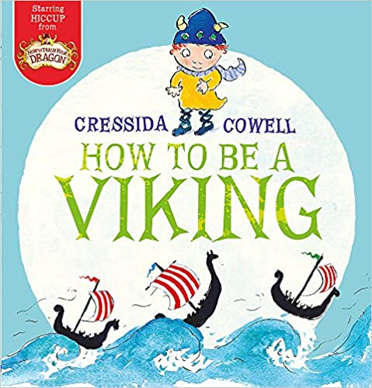 | How to be a Viking by Cressida Cowell  So begins Cressida Cowell's stories about a little Viking who cannot fit in. Unlike his dad, Stoick the Vast, Hiccup is tiny, thoughtful and polite and scared of almost everything - especially of going to sea for the very first time. But go he must... So who will save the day when everything goes wrong aboard ship and all the big Vikings lose their cool? This wonderfully witty fable will delight all those who have ever faced up to their worst fears.
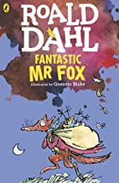 | Fantastic Mr Fox by Roald Dahl  Boggis is an enormously fat chicken farmer who only eats boiled chickens smothered in fat.  Bunce is a duck-and-goose farmer whose dinner gives him a beastly temper.  Bean is a turkey-and-apple farmer who only drinks gallons of strong cider.  Mr Fox is so clever that every evening he creeps down into the valley and helps himself to food from their farms - and those GHASTLY farmers can't catch him!  Now the farmers have hatched a plan to BANG-BANG-BANG shoot Mr Fox dead! But, just when they think Mr Fox can't possibly escape, he makes a FANTASTIC plan of his own . . .
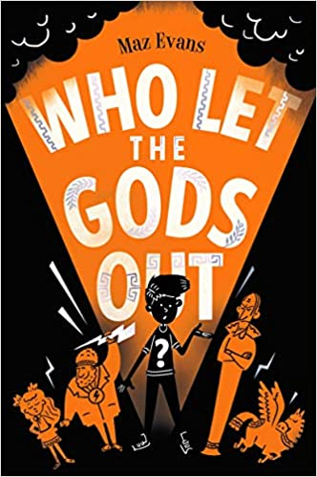 | Who Let the Gods Out? By Maz Evans  When Elliot wishes upon a star, he doesn't expect a constellation to crash into a dungheap on his family farm.  The star is Virgo. She thinks she's perfect. Elliot doesn't. And together they release Thanatos, evil Daemon of Death ... epic fail.  They need the King of the Gods and his noble steed. Instead, they get a chubby Zeus and his high horse Pegasus.  Are the Gods really ready to save the world? And is the world really ready for the Gods?
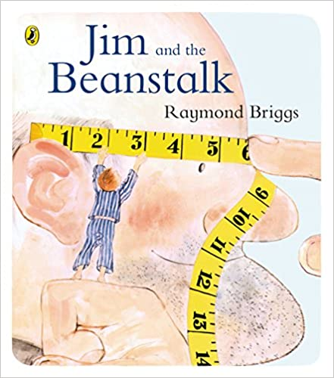 | Jim and the Beanstalk by Raymond Briggs  A re-telling of the classic children's story by the author and illustrator of the best-selling Snowman. Jim finds a beanstalk growing outside his window one morning, and follows his famous predecessor up to the top . . .
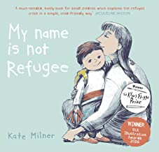 | My Name is not Refugee by Kate Milner  A young boy discusses the journey he is about to make with his mother. They will leave their town, she explains, and it will be sad but also a little bit exciting. They will have to say goodbye to friends and loved ones, and that will be difficult. They will have to walk and walk and walk, and although they will see many new and interesting things, it will be difficult at times too.
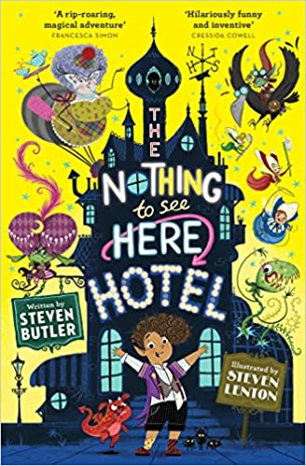 | Nothing to see here hotel by Steven Butler  Welcome to The Nothing to See Here Hotel! A hotel for magical creatures, where weird is normal for Frankie Banister and his parents who run the hotel.  When a goblin messenger arrives at The Nothing to See Here Hotel, announcing the imminent arrival of the goblin prince Grogbah, Frankie and his family rush into action to get ready for their important guest. But it soon becomes obvious that the Banister family are going to have their work cut out with the demanding prince and his never-ending entourage, especially when it turns out the rude little prince is hiding a secret...
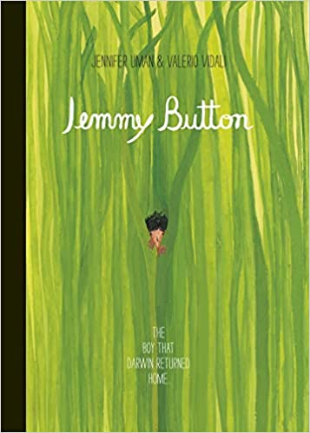 | Jemmy Button by Valerio Vidali  Inspired by the life of Jemmy Button - a native of Tierra del Fuego who was  brought to England in the mid-1800s to be 'educated' and 'civilised' by Captain Robert FitzRoy - this book illustrates Jemmy's bizarre encounters and his return  back home. Collaborating across continents, without a common language, Valerio's  precision and Jennifer's primitive style have resulted in a story unlike any other.
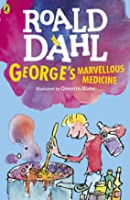 | Georges Marvellous Medicine by Roald Dahl  WARNING: DO NOT try to make George's Marvellous Medicine yourselves at home. It could be dangerous...  George Kranky's Grandma is a miserable grouch. George really hates that horrid old witchy woman.  One Saturday morning, George is in charge of giving Grandma her medicine. So-ho! Ah-ha! Ho-hum! George knows exactly what to do.  A magic medicine it will be! One that will either cure her completely of her horrible grouchiness . . . or blow off the top of her head

